***Experiment 3 Output***

This experiment sets up an AWS S3 bucket to upload, verify, and download data. It demonstrates secure and scalable cloud storage management.

***Running Docker***

***Running AWS using Localstack***

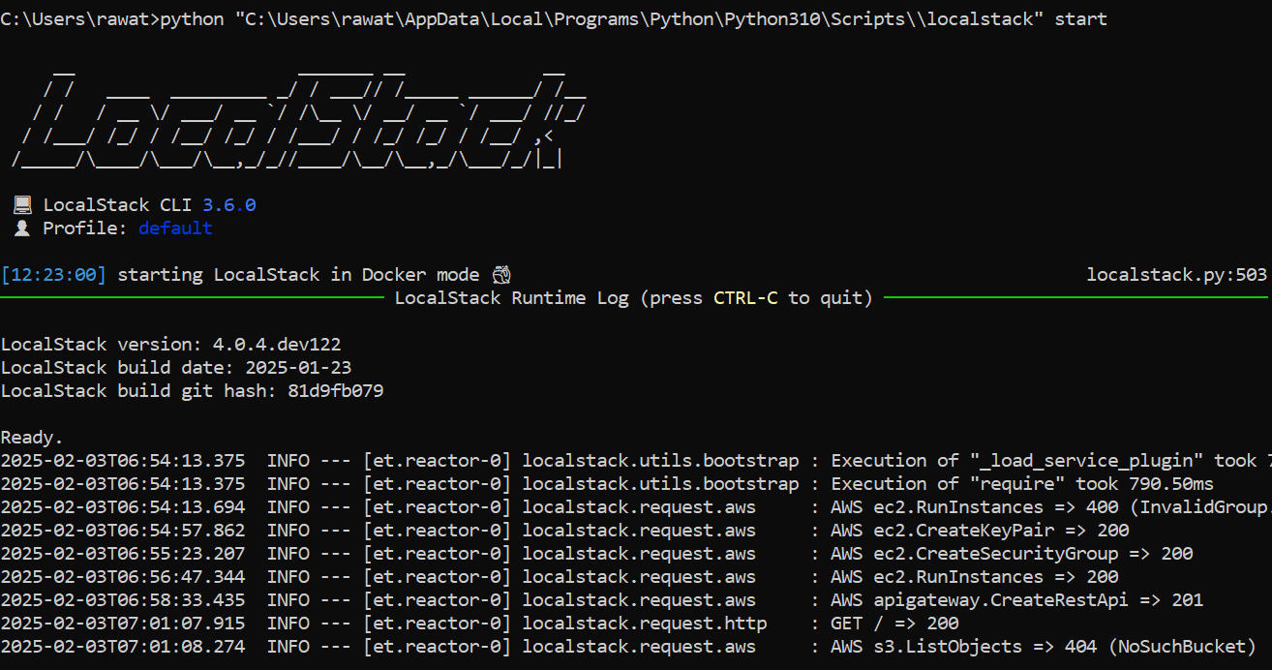

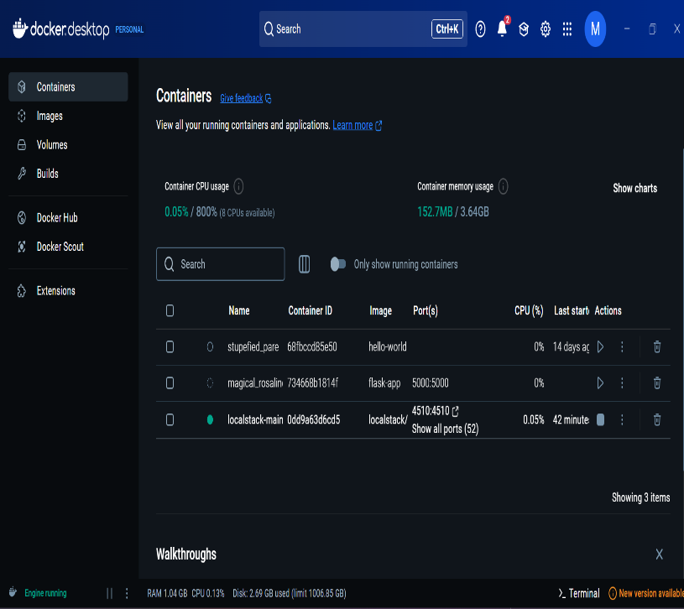

***Fig 2: Docker for Desktop in windows***

**Fig 1: Starting Localstack in the Console**

***Creating and Storing Data in S3 Bucket***

***Contents in Bucket***

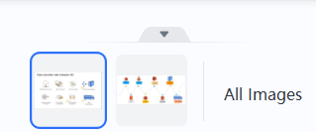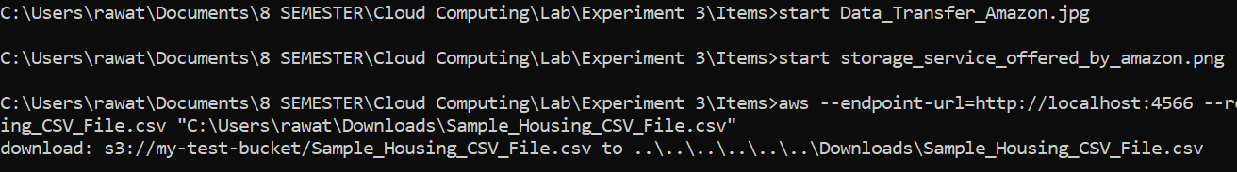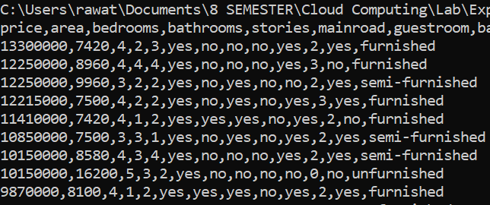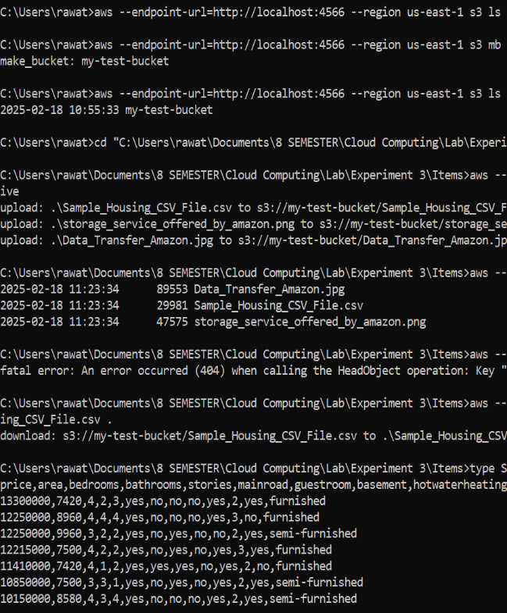

***Fig 5: Images Output***

***Fig 3: S3 Bucket and contents***

***Fig 4: Printing CSV File***